Disability Sports, Health and Wellness Virtual Conference
Page 1

CONFERENCE PROGRAM
Tuesday April 13, 2021
Registration Link: https://bit.ly/30Zufx9

SCHEDULE

4:00 PM - 5:00 PM: Welcome & Introduction
­ Dr. Labros Sidossis
­ Javier Robles
­ Keynote Address - Kevin Broussard
­ Moderators, Jennifer Demby and Kevin Orcel
­ Panelists Q&A

5:10 PM - 6:00 PM: Breakout Round 1
­ Yoga
­ Blind Athletes Inc.
­ Exercise, Mental Health, & Mind Body Connection
­ Power of Sports For Children with Disabilities (ages 3-12)
­ Exercise, Wellness & Nutrition

6:10 PM - 7:00 PM: Breakout Round 2
­ Individuals with Intellectual Disabilities & their Families
­ Power of Sports For Children with Disabilities (ages 13-22)
­ Barriers to Participation In Sports and Recreation for Adults on the Autism Spectrum
­ What To Do During Covid-19
­ Paralympian Panel
Page 2

Welcome & Introduction

Dr. Labros Sidossis,
Chair of Department of Kinesiology & Health

Javier Robles,
Professor at Rutgers University & Director of the Center for Disability Sports, Health & Wellness

Moderators

Coach Jennifer Demby
Jennifer Demby is a Co-Founder and Director of Sports of Blind Athletes Inc., a nonprofit New Jersey Sports Club for blind and vision impaired athletes. She is a ‘96 US Olympian and ‘95 Pan-Am gold medalist as a goalkeeper for the US National Handball Team. Jennifer is a Certified Level 1 Coach with USA Track and Field, and Certified in SafeSport.

Kevin Orcel
Kevin Orcel is a visually impaired athlete born in Haiti. He earned his master’s in Recreation & Sport Management at Florida International University. Kevin attended Florida School for the Deaf and the Blind while being on the Varsity Wrestling team and Men’s Goalball team.

Keynote Speaker - Kevin Broussard
Born with a rare retinal disorder, Kevin has been legally blind since as far back as he can remember. The target of bullying and ridicule as a child due to his vision led him down a dark road of depression and anxiety. Eventually, Kevin found an outlet through the world of adaptive sports. In track and field, Kevin has amassed 3 world titles, 3 Pan American titles, and the US Paralympic record in the discus. He also competed internationally for the USA Judo Paralympic team for 3 years. Kevin currently serves as the Programs and Finance Director for the US Association of Blind Athletes.
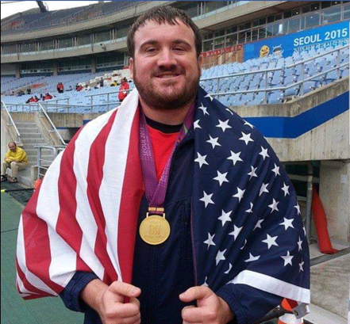
Page 3

Panelists

Sherlock Washington
Sherlock Washington is a 1990 US Paralympian, an All-star team player, and Co-founder of Blind Athletes in New Jersey. He was diagnosed with Retinitis Pigmentosa and has been blind due to it. He is respected and well-known for his athleticism. Sherlock is well known for his athleticism in the visually impaired community. He is a co-founder of Blind Athletes Inc, a non-profit sports club for the visually impaired in New Jersey currently serves as a board member. Having made the U.S. Paralympic Team in 1990, he journeyed to the Netherlands where he won the bronze (3rd place) medal in the high jump. Sherlock also played goal ball from 1986-1995 and his team received the gold (1st place) medal in the 1993 national competition.

Karin Korb
Karin Korb is a 2- time Paralympian and a 10-time member of the USA World Team. She was the first person with a disability to receive a Division 1 athletic scholarship to Georgia State University to play intercollegiate wheelchair tennis and has assisted other universities in creating their own wheelchair tennis and varying adapted sports programs. Prior to entering Georgia State and earning her master's degree, Korb graduated from Kean University in her birth state, New Jersey. She currently works in policy, advocacy and public affairs with Lakeshore Foundation, a designated Olympic and Paralympic training site.

Nick Panzarino
Nick Panzarino is a Special Olympics New Jersey athlete from New Providence who has competed in track and field and bowling. Nick represented SONJ at the 2018 USA Games in Seattle, representing Team New Jersey in track and field. Nick also participates in Rutgers Unified Sports. He will be accompanied on the panel by his mother, Patti, who has numerous years of experience teaching children with disabilities.

Bradley Snyder
In 2011, Brad suffered complete vision loss as the result of a combat injury in Afghanistan. Within a year, however, Brad earned a spot on Team USA, and swam to gold in the London Paralympics. Brad’s mission is to study and apply virtue in all aspects of life in order to empower society’s pursuit of happiness. When he’s not training or competing, Brad serves as a fellow in the Stockdale Center for Ethical Leadership at his alma mater USNA. He is pursuing a Ph.D. in Public Policy with the intention of becoming a tenured professor in the leadership and ethics department. Brad hopes to leverage his personal experiences along with his developed expertise to inspire future generations of leaders and warriors.
Page 4

Breakout Round 1

Yoga - Natalie Schultz-Kahwaty, PhD

Description
This class will be a combination of Yoga, Mindfulness, Brain Dance, and Motivation all from a chair. It will explore movement while in a seated position that will stretch the body, then connect the brain and body with some fun dance, and then quiet everything with the use of breath and imagery. The class is designed to make you smile and be enjoyable and think about the movement in a new and invigorating way.

Biography
After completing her PhD in Advance Studies in Human Behavior, Natalie was trained through the Dance for PD® program developed by the Mark Morris Dance Group and the Brooklyn Parkinson Group. Natalie wrote the class Adaptive Movement Through Dance from her experience in working with many populations that have trouble moving, specifically with those who have PD and Autism. These redesigned classes are for people who cannot get on the floor or stand for an hour because they have various physical limitations. With this modified model, Natalie teaches the Dance for PD® classes at Rutgers University on Saturdays and at various other community centers in PA and NJ. Natalie has also taught as an Adjunct Professor for the past 20 years in many colleges. Natalie is also a certified in AFAA Primary Group Certification and has been a fitness instructor for the past 17 years.

Links
https://www.masongross.rutgers.edu
Page 5

Blind Athletes Inc. - Coach Jennifer Demby, Kevin Orcel & Sherlock Washington

Description
Panel discussion to include information about sports for the blind and vision-impaired and how to get involved in local and national, competitive, or recreational sports activities. Blind Athletes Inc, a 501c (3) nonprofit New Jersey sports club for blind and vision impaired athletes focused on creating transformative opportunities, enabling the pursuit of excellence, empowering happiness through adaptive sports, and promoting fitness, friendship, and fun.

Biographies
Coach Jennifer Demby
Jennifer Demby is a Co-Founder and Director of Sports of Blind Athletes Inc., a nonprofit New Jersey sports club for blind and vision impaired athletes. She is a ‘96 US Olympian and ‘95 Pan-Am gold medalist as a goalkeeper for the US National Handball Team. Jennifer is a Certified Level 1 Coach with USA Track and Field, and Certified in SafeSport.

Kevin Orcel
Kevin Orcel is a visually impaired athlete born in Haiti. To receive the best medical treatment and education, his parents moved to the United States, Kevin was only 10 years old. He attended Florida School for the Deaf and the Blind, where he was on the Varsity Wrestling team and the Men’s Goalball team. He then went on to earn his Master’s in Recreation & Sport Management at Florida International University. Kevin is now an Account Executive of Group Events with the New Jersey Devils, the team captain for Blind Athletes Inc. 5-a-side soccer, a Para Track & Field Athlete, and a Member of the New Jersey Thunder Men’s Goalball team.
Sherlock Washington
Sherlock Washington is a 1990 US Paralympian, an All-star team player, and Co-founder of Blind Athletes in New Jersey. He was diagnosed with Retinitis Pigmentosa and has been blind due to it. He is respected and well-known for his athleticism.

Links: https://www.blindathletes.org/
Page 6

Exercise Mental Health and Mind Body Connection - Amanda Buchner

Description
The National Alliance on Mental Illness (NAMI) is the nation’s largest organization dedicated to providing support, education, and advocacy for people affected by ongoing mental health conditions and their families. This workshop will cover topics to include (1) benefits of exercise on mental health, (2) self-efficacy and athletics, and their role in mental health recovery, (3) athletic participation as a means of developing and enhancing interpersonal skills, (4) school-age athletics as a gateway to lifetime fitness habits, and (5) how physical education classes and educators can accommodate students with mental health issues.

Biography
Amanda Buchner earned her BA in Psychology/Fine Arts from St. Michael's College, and her M.Ed. in Athletic Training at Plymouth State University. Amanda taught health education/life skills at both the high school and college level, and has been involved with sports her entire life from playing, coaching, and as an athletic trainer. Amanda believes that healthy living encompasses the whole person, and that the mind/body connection is crucial to achieving this balance. She is passionate about advocating for those struggling with mental/behavioral health issues and fighting to remove the stigma associated with these types of conditions.

Links: https://www.naminj.org/
Page 7

The Power of Sports for Children with Disabilities (ages 3 - 12) - Coach Trisha Yurochko

Description
This workshop is intended for parents of children ages 3 – 12 years of age whose child has a diagnosis of a physical disability. The panelists will discuss what it was like raising or being a child with a congenital or acquired disability and how involvement in sports made them who they are today.

Biographies
Coach Trisha Yurochko
Trisha Yurochko has been employed by Children’s Specialized Hospital for over 40 years. During that time she has held several different positions and for the last 39 years she has been involved with the Children’s Lightning Wheels PSC, the hospital’s sports team for athletes ages 7 – 22 years of age for those with physical disabilities. For the last 21 years she has been the head coach of the team. Trisha has also helped develop and coach the youth wheelchair sports program for NY Road Runners. She is a USATF National Level Official with Disability Specialty; on-course official for the Pro-Wheelchair division for the NYC Marathon; a USATF Level 1 Track & Field Coach; US Paralympics & Adaptive Sports USA national level technical classifier; USA Archery Level 1 Instructor; PADI certified Rescue Diver. She serves on the Tri-State Wheelchair & Ambulatory Athletics and sits on the Board of Directors for Stay-Focused, a scuba-diving program for teens and young adults with physical disabilities. Trisha was one of the 10 finalists in USA Weekend Magazine Most Caring Coaches; she helped develop the initial disabilities curriculum for the USATF officials’ course & test.
Eva Niemeijer
Athlete, advocate, and masters level student at Rutgers University who has a congenital disability.
Jessica Galli Cloy
PA 4-time Paralympian and multiple world record holder who has an acquired disability.
Ina Niemeijer
Parent
Phil Galli
Parent

Links: www.Children's-specialized.org
Page 8

Exercise, Wellness & Nutrition- Dr. Brandon Alderman & Dr. Anthony Delli Paoli

Description
This workshop is intended for anyone who is interested in the effects of physical activity and exercise on cognitive and brain health, with a particular emphasis on individuals with a variety of disabilities (e.g., depression, autism, ADHD). The panelists have both conducted research on the physical and mental health benefits of physical activity, and will show some of this evidence and wrap-up with a discussion about optimal physical activity prescriptions for individuals across the lifespan.

Biographies
Dr. Brandon Alderman
Dr. Brandon Alderman is an Associate Professor of Kinesiology and Health and a member of the Center of Alcohol and Substance Use Studies at Rutgers University. Dr. Alderman has established a patient-oriented research program to study how exercise and other behavioral interventions can be used to enhance physiological, neurocognitive and psychological resilience. His research program incorporates psychophysiological and cognitive neuroscience techniques, including event-related potentials (ERPs) and impedance cardiography, to better understand acute and chronic adaptations to exercise, and how knowledge of these adaptations can be applied to intervention development.
Dr. Anthony Delli Paoli
Dr. Anthony G. Delli Paoli is an Assistant Professor at Rutgers University in the Department of Kinesiology and Health and serves as Director of Research for the Youth Sports Research Council. Dr. Delli Paoli is interested in how physical activity may help those who experience social challenges, such as being ignored, left out or rejected. This research focuses on young adults, typically developing children, and children with ADHD. An overarching goal of this research is to promote quality physical activity experiences for young people such that they translate into active and healthy lifestyles into adulthood.

Links: www.Kines.rutgers.edu
Page 9

Individuals with Intellectual Disabilities and Their Families - Linda Newman, Paul Goobic, & Sam Cyliax

Description
Linda and Sam’s session will discuss family involvement in sports for individuals with disabilities. Linda will discuss how, as a parent, she aligned with an existing organization and was able to start and grow their programs. Linda will discuss how parents can build sporting programs. Sam will discuss opportunities and ways for families to keep their athletes engaged during COVID by explaining what Special Olympics is offering, as well as best practices at home to ensure optimal health and wellness for their child with disabilities.

Biographies
Linda Newman
Linda is the mom to 2 young adult men. Max, 27 has Autism and a mental health diagnosis. He is the driving force for her advocacy, Program development and volunteerism in the South Jersey Community. For over 12 years, Linda and her husband Eric have been running a Special Needs Basketball program through the Katz JCC supported by NIKE Corp. and many community volunteers. She coordinates monthly community outings Through JFCS and serves on various councils and committees to improve the lives People With Disabilities.
Paul Goobic
Serves as the Intramural & Sport Club Coordinator at Rutgers Recreation. He advises the Rutgers Unified Sports Club.
Sam Cyliax
Sam has been working for Special Olympics New Jersey for almost four years, where he started with the organization after participating in Unified Sports at Montclair State University. It gave him a passion to create a platform for athletes to achieve their dreams and to further the Special Olympics mission. Sam and his team at Special Olympics New Jersey plan and execute sporting events throughout the year that provide a competitive and inclusive environment for individuals with intellectual disabilities.

Links: https://www.sonj.org/
Page 10

Breakout Round 2

The Power of Sports for Children with Disabilities (ages 12- 22) - Coach Trisha Yurochko

Description
This workshop is intended for parents of children ages 13 – 22 years of age whose child has a diagnosis of a physical disability. The panelists will discuss what it was like raising or being a child with a congenital or acquired disability and how the involvement in sports made them who they are today.

Biography
Trisha Yurochko
Trisha Yurochko has been employed by Children’s Specialized Hospital for over 40 years. During that time she has held several different positions and for the last 39 years she has been involved with the Children’s Lightning Wheels PSC, the hospital’s sports team for athletes ages 7 – 22 years of age for those with physical disabilities. For the last 21 years she has been the head coach of the team. Trisha has also helped develop and coach the youth wheelchair sports program for NY Road Runners. She is a USATF National Level Official with Disability Specialty; on-course official for the Pro-Wheelchair division for the NYC Marathon; a USATF Level 1 Track & Field Coach; US Paralympics & Adaptive Sports USA national level technical classifier; USA Archery Level 1 Instructor; PADI certified Rescue Diver. She serves on the Tri-State Wheelchair & Ambulatory Athletics and sits on the Board of Directors for Stay-Focused, a scuba-diving program for teens and young adults with physical disabilities. Trisha was one of the 10 finalists in USA Weekend Magazine Most Caring Coaches; she helped develop the initial disabilities curriculum for the USATF officials’ course & test.
Eva Niemeijer
Athlete, advocate, and masters level student at Rutgers University who has a congenital disability.
Jessica Galli Cloy
A 4-time Paralympian and multiple world record holder who has an acquired disability.
Ina Niemeijer
Parent
Phil Galli
Parent

Links: www.Children's-specialized.org
Page 11

Barriers to Participation in Sports & Recreation for Adults on the Autism Spectrum - Christopher Manente, Alex Scheck, Angela Catillo, Scheck

Description
The opportunity to play sports and engage in other forms of active communal recreation provide numerous benefits for ensuring overall physical and psychological health and well-being. Unfortunately, many people with autism continue to be excluded from accessing inclusive opportunities to engage in sports and recreation. This presentation will explore the importance of accessibility for participation in sports and recreation for autistic adults and the related barriers. Attendees will have the opportunity to hear the first-hand perspectives of a gold-medal winning Special Olympics athlete on the spectrum and his mother on their experiences in being involved with competitive sports.

Biographies
Alex Scheck
Alex Scheck has been part of the RCAAS Scale program since July of 2017. He has worked several jobs at Rutgers including at the Rutgers Athletic Center and the Rutgers Post Office. Alex is a gold-medal winning Special Olympics athlete who has represented the state of New Jersey twice, competing in the USA games as a member of New Jersey’s soccer team in 2014 and bocce team in 2018. He has won numerous bronze, silver and gold medals for soccer, basketball, volleyball, bocce and track and field.
Angelo Catillo Scheck
Angela Scheck is a 1985 graduate of Douglass College, having majored in journalism and communications. For the past 12 years, she has been the Executive Director of the New Jersey State Bar Association, the largest professional organization representing the state’s legal community. As a parent, she helped to create a sports league for kids with disabilities when Alex was five-years-old, because no opportunities existed for active sports participation. That league has expanded and is still active today.
Dr. Christopher Manente
Dr. Christopher Manente is an accomplished practitioner, educator, and advocate who has dedicated his career to helping adults on the autism spectrum succeed within their homes and communities throughout the lifespan and across the contexts of school, work, relationships, leisure, and transportation. Dr. Manente is the Founding Executive Director of the Rutgers Center for Adult Autism Services, he is a combat veteran of the U.S. Army’s 101st Airborne Division and is a prior special education student.

Links: www.rcaas.rutgers.edu
Page 12

Covid-19, Health, Disabilities, and Survival - Javier Robles, Carol Tonks, Rose Greenblatt, Sherlock Washington

Description
Individuals with disabilities and their families were disproportionately affected by the Covid-19 pandemic. The civil rights, health, and social fabric which holds this community together were challenged like no other time in modern memory. In New Jersey, numerous advocates, parents, and organizations formed the Covid-19 Disability Action Committee. This committee’s work and eventual report have led to various changes in state government and numerous pieces of legislation to protect and empower people with disabilities. Join us for a conversation with members of the group about our findings, and our aspirations for the future.

Biographies
Javier Robles, J.D
Javier Robles is the Director of the Center for Disability Sports, Health and Wellness at Rutgers University Department of Kinesiology and Health and a Professor at the University. He is the organizer of the New Jersey Disabilities COVID-19 Action Committee and Vice President of the Latino Action Network of New Jersey; he is also a board member of the Northeast Region Board of Canine Companions for Independence. Until 2010, he served as the Deputy Director of the NJ Division of Disability Services (DDS), situated in the New Jersey Department of Human Services. He was a member of the Governor’s Blue Ribbon Panel on immigration a past Chairperson of the Drug and Alcohol Advisory Council for the Deaf, Hard of Hearing, and Disabled, a past member of the Governor’s Working Group on Latino Issues, and he served on the NJIT’s EmployMe! and Business Advisory Council. He was an organizer for both New Jersey’s first Latino Health Conference and the Latinos with Disabilities Employment Conference and was the planning group’s Chairperson for the Governor’s Conference on Employment of People with Disabilities and for the African Americans with Disabilities Employment Conference.
Carol Tonks
Carole Tonks has over 25 years of experience in the disability community. She has served for the past 13 years as the Executive Director for the Alliance Center for Independence (ACI) in Edison, New Jersey. ACI is a center for independent living serving disabled individuals and their families in Middlesex, Somerset, and Union counties. Carole has been involved in emergency preparedness efforts for the past 10+ years. Carole worked for 13 years at the NJ Council on Developmental Disabilities, where she was the coordinator of their statewide advocacy project. Carole became involved in disability rights after her son was born with autism.
Rose Greenblatt
Rose Greenblatt is a proud alumni of Rutgers University School of Environmental and Biological Sciences. She is currently a graduate student at Washington University in St. Louis, working towards her clinical doctorate in occupational therapy. She has worked as a Direct Support Professional and Support Coordinator through the Department of Developmental Disabilities and has assisted Javier in teaching his course, “Movement Experiences for Individuals with Disabilities”. Rose is currently serving as the DAC’s facilitator and administrator.
Page 13
Sherlock Washington
Sherlock Washington is a 1990 US Paralympian, an All-star team player, and Co-founder of Blind Athletes in New Jersey. He was diagnosed with Retinitis Pigmentosa and has been blind due to it. He is respected and well-known for his athleticism.

Links:
Page 14

Paralympian Panel - Joe Delgrave, Hope Lewellen, Karin Korb

Description
Physical activity and wellness are at the core of this panel discussion. Learn from our Paralympic panelists on how they use their platforms to spark the curiosity of children and adults on the benefits of a lifetime commitment to physical activity, wellness and sport. They will discuss the advantages of being a professional athlete as well as the barriers they encounter to achieving the overall mind, body and spiritual successes we all aspire to create within ourselves.

Biographies
Joe Delgrave
Joe Delgrave has over 13 years of experience on the National Wheelchair Rugby Team. He is a Paralympic bronze medalist, and as a captain for over eight years, he has proven leadership as the team has been podium contenders each year. With that athletic mentality, Joe captivates and motivates people to find that competitive fire within themselves no matter the obstacle. Joe works with leaders and organizations to develop plays and action plans for success as we all strive to get that Gold.
Hope Lewellen
Prior to her accident Hope Lewellen has always been a multi-sport athlete. She was an ASA junior Olympian in Fast pitch softball and founding member of Orland Park Sparks softball, a basketball player and competitive swimmer. During her career in Aircraft Mechanics for Continental Airlines, Hope sustained a traumatic accident in 1989 where she became an above the knee amputee. She was instrumental in the creation of Patient Zero prosthetic liners and was introduced to wheelchair tennis. She earned her position on four Paralympic USA Delegations in 1996, 2000, and 2004 for sitting volleyball and wheelchair tennis. She is certified as a Level 1 Krav Maga Instructor (USKMA). She was a member of the USA Para Shooting and is currently employed at Shoot Point Blank offering private basic firearm safety.
Karin Korb
Karin Korb is a 2- time Paralympian and a 10-time member of the USA World Team. She was the first person with a disability to receive a Division 1 athletic scholarship to Georgia State University to play intercollegiate wheelchair tennis and has assisted other universities in creating their own wheelchair tennis and varying adapted sports programs. Prior to entering Georgia State and earning her master's degree, Korb graduated from Kean University in her birth state, New Jersey. She currently works in policy, advocacy and public affairs with Lakeshore Foundation, a designated Olympic and Paralympic training site.
Page 15
Thank you to all our amazing partners without which this conference would not be possible. We appreciate their dedication to individuals with disabilities and their families at Rutgers University and the state of New Jersey.

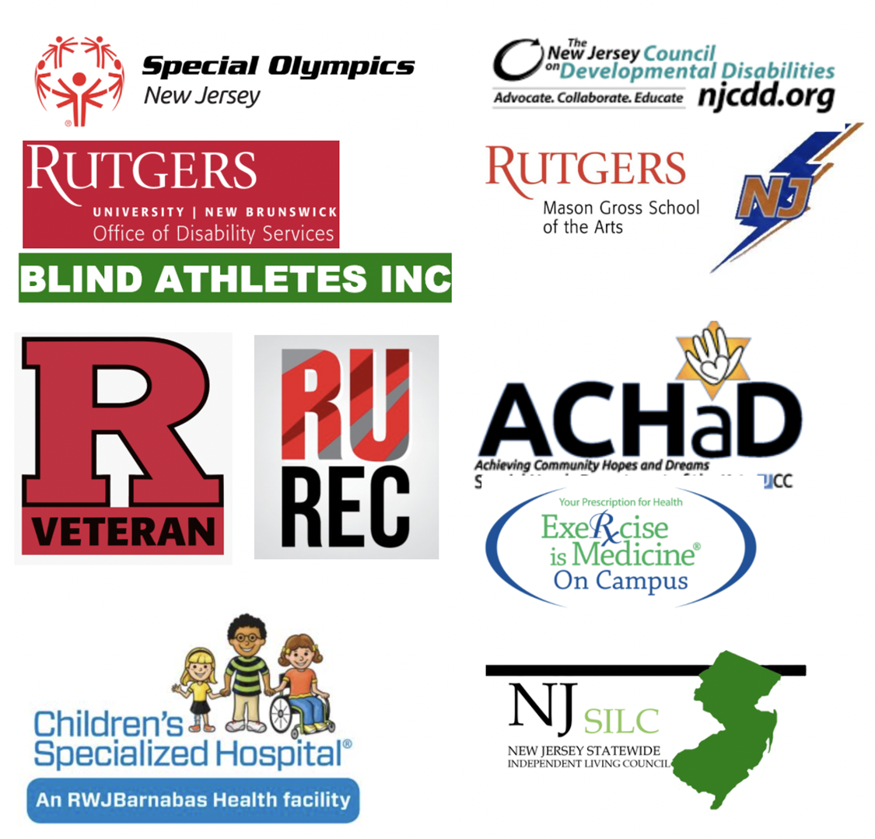
[Begin alt text] Logos for Special Olympics New Jersey, The New Jersey Council on Developmental Disabilities, Rutgers University Office of Disability Services, Rutgers Mason Gross School of the Arts, Rutgers Veteran, RU Recreation, Children's Specialized Hospital An RWJ Barnabas Health facility, Blind Athletes Inc., Achieving Community Hopes and Dreams, Exercise is Medicine, New Jersey Statewide Independent Living Council. [End alt text].
Page 16

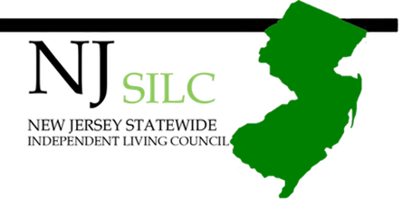
Page 18
